**Project 1 Report**

**Problem 1:** Does weather impact accident rate in New York?

Findings:

1. Number of collisions is highest between 20 – 25 °C temperature range.
2. Highest number of collisions occur between 5-15 °C on rainy days.
3. Highest number of collisions occur between 0-5 °C when there is sleet/hail/freezing rain/snow.

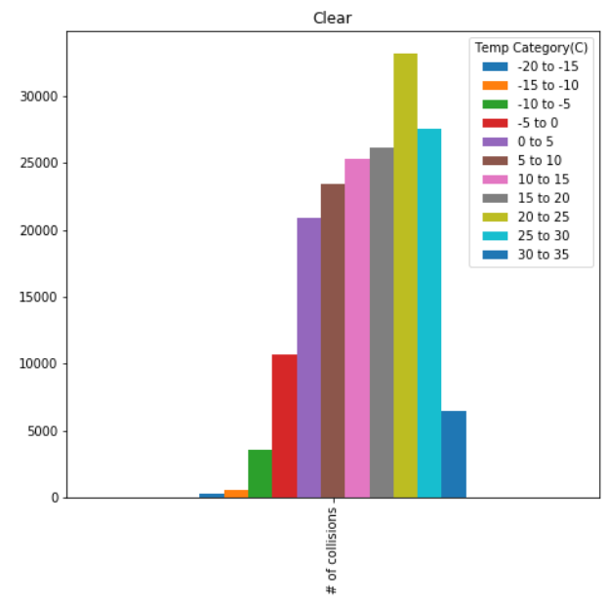

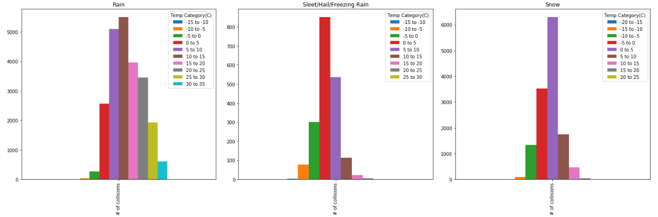

**Problem 2:** Does number of cab rides booked in New York vary with weather conditions?

Findings:

1. Low temperatures didn’t result in high cab rides; as initially anticipated, we therefore assume that this must mean that they worked remotely/had a snow day.
2. Cloudy days have highest number of cab rides booked.

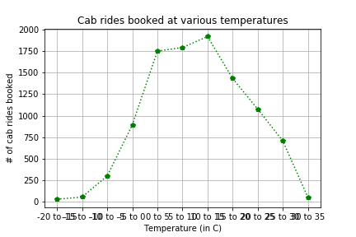

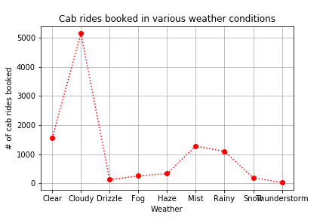

**Problem 3:** How energy consumption changes with the temperature conditions and weather?

Findings:

1. A/C requires more energy than heating does, had expected heating to require more energy than A/C (This is electrical energy only, further analysis into what do New Yorkers have installed in their apartments is required).
2. Highest Consumption rates are between 2pm to 8pm in the evening & the lowest between 2-5am🡪 Time of the Day matters.

